7-2 Project Two Submission

John Schmidt
Southern New Hampshire University
CS-320: Software Test, Automation QA
Professor Rob Tuft
October 13, 2026
My initial approach to the testing project was to ensure that I was meeting all the requirements for each of the features. The initial requirements for each of the features were clear on what was needed to ensure proper functionality. For example, the Contact class needed to consist of a Contact ID, First Name, Last Name, Phone, and Address. The Contact ID, First Name, and Last Name all had the requirements that they cannot be longer than 10 characters. The Phone Number cannot be longer than 10 digits. Lastly, the Address field could be no longer than 30 characters. The one big thing that all of these have in common is that the fields cannot be null. The Task Class and the Appointment Class both had similar requirements for the fields that were needed within them.
Continuing to use the Contact class as an example, you can see from the code block:
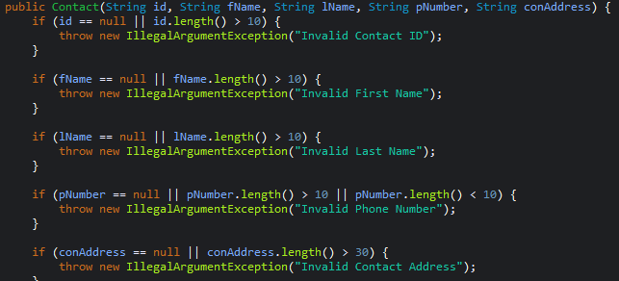
In this code block I set the requirements for each of the values and added an error if the field was too long. One of the fields in this code block, the pNumber for the phone number, could have been established better. In my code I used “pNumber.length() >10 || pNumber.length() < 10” to ensure that the phone number was not longer than 10 characters. However, the requirement for the phone number was to ensure that it was 10 digits not characters. Because of this, in my Contact class the use would be able to enter “ABCDEFGHIJ” and the system would classify it as a valid phone number.
Using JUnit to test coverage gave me the ability to understand which lines of my code were being executed and tested. In the system that I wrote I got a coverage total of 81.1%. This meant that of the total instructions of 2,551 I had a total of 2,069 being executed.
This tells me that throughout the project I had a total of 482 instructions that were missing. Using the coverage tool with JUnit I was able to break this coverage down and see what portions throughout my project that I had missing instructions. When I was researching where these were missing from, I was able to see that were spread out throughout my test files, Contact, and ContactService.
The software testing techniques that I used throughout this project would be Static Testing and White-Box Testing. Static testing was used as inspections that check the code for syntax errors or structural issues. I used White-Box Testing as conditional coverage to test the statements to ensure that they were running correctly to ensure that the requirements that I was given were met.
Other testing options that I did not use for this project include Black-Box Testing and Experience-Based Testing. Black-Box Testing is used to test the classes as either valid or invalid using Boundary Value Analysis. Using Boundary Value Analysis, you can test edge cases including min, max, and just inside/outside. Experience-based testing will allow testers to be able to try to predict areas that may be prone to defects. This will allow for better user experience of the product.
Throughout the project I attempted to adopt two different mindsets. The first mindset being that of the software developer. The second mindset was that of the software tester. While thinking like a software developer I had to ensure that the requirements that I was given were being met. I also had to ensure that the functionality of the project was sound without making assumptions. Understanding that the whole project would be all interconnected and that a small change or failure in one section could have cascading negative effects in other sections. While thinking as a software tester I had to try to keep an unbiased approach while setting up the tests. This would help me to ensure that the testing that I was implementing was not biased to my work as the software developer.
Being committed to quality in any role that would be working in is very important. Whether you are working as a software developer or tester, cutting corners will only lead to detrimental failure later. These failures could be burnout from other developers having to try to understand the code that you have written or testers having to try to work around unintended side effects. One of the major ways that we are able to avoid technical debt is to have a strict Definition of Done. This will allow the development team to have a strict “finish line” for the features that were being worked on. Because of this, the development team won’t have to worry about having goals that they will never be able to achieve because they are constantly changing.

